The Role of Object Affordances and Center-of-Gravity Effects in Eye Movements Towards Isolated Daily-Life Object

Lotje van der Linden, Sebastiaan Mathôt and Françoise Vitu
Laboratoire de Psychologie Cognitive, Aix-Marseille Université, CNRS, Marseille, France

Corresponding author:
Lotje van der Linden
Laboratoire de Psychologie Cognitive (LPC)
CNRS, Université de Provence, UMR 7290
Centre St Charles, Bâtiment 9, Case D
3 place Victor Hugo
13331 Marseille, cedex 03
e-mail address: l.vanderlinden@cogsci.nl
telephone number: +33 4 13 55 09 66

Abstract
The purpose of the current study was to investigate to what extent low-level versus high-level effects determine where the eyes land on isolated daily-life objects. We operationalized low-level effects as saccadic averaging towards the objects' center-of-gravity (CoG), and high-level effects as visuomotor priming by object affordances. Participants were instructed to make vertical saccades towards peripherally presented graspable objects (e.g. a hammer), and to categorize them with a button press. Objects were rotated such that their graspable part (e.g. the hammer's handle) pointed either towards the left or the right, whereas their action-performing part (i.e. the hammer's head) pointed towards the other side. We found that initial saccades that occurred early in time were neither biased towards the objects' graspable part, nor towards its action-performing part. Instead, participants' eyes landed near the center of gravity of the object. Only initial saccades occurring later in time, as well as subsequent within-object refixations, were subject to high-level influences, being significantly biased towards the objects' action-performing part.

Keywords
Saccadic landing positions, Refixations, Center of gravity, Object affordances, Visuospatial attention
The Role of Object Affordances and Center-of-Gravity Effects in Eye Movements Towards Isolated Daily-Life Object
Vision is an activity. What you look at determines what you see. But what determines what you look at? On the one hand, you make rapid saccadic eye movements towards certain parts of a visual scene because they are high in contrast, or bright in color (Itti & Koch, 2000, 2001; Itti, Koch, & Niebur, 1998). These saccades are reflexive and depend solely on the scene's low-level properties. On the other hand, you make saccades based on the scene's high-level properties, such as the identity of the objects in it (see e.g. Nuthmann & Henderson, 2010). The extent to which both factors contribute to eye guidance has been the subject of debate for many years (for reviews see e.g. Henderson, 2003; Rayner, 1998; Rayner, Liversedge, Nuthmann, Kliegl, & Underwood, 2009; Tatler, Hayhoe, Land, & Ballard, 2011). In this debate, the influence of low-level properties is typically contrasted with the influence of semantic knowledge (Loftus & Mackworth, 1978; Henderson, Weeks Jr, & Hollingworth, 1999) or current goals (Land & Hayhoe, 2001; Land, Mennie, & Rusted, 1999). In the current study, we investigate this decades-old issue in a new way, by contrasting low-level effects with the effect of visuomotor priming by object affordances. Visuomotor priming refers to the notion that the mere sight of an action-related object, such as the teapot on your desk, automatically activates a motor program associated with it (for behavioural studies, see e.g. Craighero, Fadiga, Umiltà, & Rizzolatti, 1996; Tucker & Ellis, 1998, 2001; for neuroimaging studies, see e.g. Chao & Martin, 2000; Grèzes, Tucker, Armony, Ellis, & Passingham, 2003). Although visuomotor priming is a higher-level process (i.e. it does not simply result from the stimulation of visual receptors, but requires some form of object recognition, however basic, instead), it is generally assumed to occur automatically and non-voluntarily (e.g. Handy, Grafton, Shroff, Ketay, & Gazzaniga, 2003; Tucker & Ellis, 2001). Crucially, it has been suggested that such object affordances draw the eyes (Myachykov, Ellis, Cangelosi, & Fischer, 2013) and visuospatial attention (Roberts & Humphreys, 2006; see also Handy et al., 2003) towards the action-related part of the object. Our first purpose was to systematically test this claim. Secondly, we aimed to investigate the time course of any action-related bias, and to compare it with the time course of the effect of a purely low-level property of the object: its center of gravity. To this end, we presented participants with isolated photographs of graspable objects and investigated where the eyes landed relative to the objects' center of gravity.

High-Level Object-Affordance Effects
Several researchers have proposed that visuomotor priming biases visuospatial attention. Intriguingly, however, there is little agreement on the direction of the predicted effect. Whereas Myachykov and colleagues (2013) found that the eyes are automatically drawn towards an objects' graspable part (i.e. the handle of a teapot), Roberts and Humphreys (2006) found an attentional shift in the direction of the action that is implied by the object (i.e., towards the pouring part of a teapot). We will refer to these possibilities as the 'handle-affordance' and the 'action-direction' hypothesis, respectively.
According to Gibson (1979) people observe objects in terms of their potential usage. He coined the term affordances to refer to the action possibilities offered by the environment (Gibson, 1977; for more recent perspectives, see e.g. Tucker & Ellis, 1998, 2001). To investigate this, Myachykov and colleagues (2013) measured eye movements while participants viewed and categorised graspable objects. They found that participants spent proportionally more time looking at an object's handle than at other parts, even though the (location of the) handle was irrelevant for the task. From these results, the authors concluded that an object's graspable part automatically captures visuospatial attention (Myachykov et al., 2013).
In direct contrast to the handle-affordance hypothesis, Roberts and Humphreys (2006) reasoned that action-related objects should bias visuospatial attention in the direction of the action implied by the object. For example, viewing a hammer would imply the action 'hammering', which induces an attentional shift towards the hammer's head rather than its handle. After all, in daily life that would be the most probable location to find the (to-be-hammered-on) nail. To test their prediction, Roberts and Humphreys (2006) used a Posner-cueing paradigm (Posner, Snyder, & Davidson, 1980) in which graspable objects functioned as central cues. The authors predicted, and found, a cueing effect at the action-direction side of the object (e.g. at the head, but not at the handle, of a hammer). They concluded that visuospatial attention is biased towards the direction of the action implied by the object (Roberts & Humphreys, 2006). Interestingly, Vainio and colleagues (2007) employed a similar paradigm (although to test the hande-affordance hypothesis), and did not find a bias to either side of the object.

A Low-Level Center-of-Gravity Effect
In visual displays containing two simple shapes, saccades typically reveal a so-called global effect: Even though participants aim for one of the two stimuli, their eyes deviate towards the other stimulus, and land on a location in between the two (Coren & Hoenig, 1972; Findlay, 1982). This systematic landing error is typically interpreted as a tendency of the eyes to land on the center of gravity (CoG) of the visual field. For example, Findlay (1982) demonstrated that when two targets differ in size, the eyes do not land exactly at the midpoint between the two, but deviate towards the largest target. Likewise, the deviation from the midpoint is stronger for brighter stimuli (Deubel, Findlay, Jacobs, & Brogan, 1988; for reviews see Vitu, 2008; and Van der Stigchel & Nijboer, 2011).
The neural basis of the global effect is assumed to be the superior colliculus, a brainstem region involved in saccade generation. The superior colliculus contains retinotopically organized motor maps, of which the neurons have large and overlapping receptive fields. As a consequence, activity stemming from two proximally presented visual stimuli combines into one central peak of activity. If this peak of activity subsequently triggers a saccade, the eyes land in between the two stimuli (Findlay & Walker, 1999; Van Opstal & Van Gisbergen, 1989). It has been suggested that such saccadic averaging is the 'default mode' of the visual system (Vitu, 2008), which can only be overcome if saccadic programming time is sufficiently long (such that competition between two stimuli is resolved in favor of one of them). In line with this idea, the global effect is particularly likely to occur for saccades that are executed very quickly. When latencies increase, saccades become more accurate and less susceptible to the global effect (Coëffé & O’Regan, 1987; Vitu, Lancelin, Jean, & Farioli, 2006).
If the global effect is indeed a universal phenomenon (Vitu, 2008), its occurrence should not be limited to displays containing two simple stimuli. In agreement with this idea, several studies have shown that the CoG of a visual display even predicts where the eyes land during more natural behavior such as reading (Vitu, 1991), visual search (Zelinsky, 2008; Zelinsky, Rao, Hayhoe, & Ballard, 1997), and scene viewing (Findlay & Brown, 2006; Melcher & Kowler, 2001). However, of most interest for the current study is whether the eyes are also drawn towards a display's CoG, when the display only contains a single stimulus. (Note that here the CoG account predicts an on-stimulus landing position instead of an in-between-stimuli landing position). Several studies demonstrated that this is indeed the case: When participants were asked to move their eyes towards a line drawing of a simple shape, their eyes landed at the stimulus' CoG (He & Kowler, 1991; Kaufman & Richards, 1969; Kowler & Blaser, 1995; Richards & Kaufman, 1969). Strikingly, however, to the best of our knowledge it has never been investigated whether the same is true for eye movements that are made towards isolated daily-life objects rather than simple shapes.
Although not to test the CoG hypothesis, some researchers did measure initial landing positions on isolated daily-life objects. Firstly, Henderson (1993) provided participants with arrays of line drawings of objects and found that landing positions were clustered around the centers of the objects. The fact that eye movements tend to land at the center of objects was later confirmed by studies using arrays of photographs of real objects (instead of line drawings, Foulsham & Underwood, 2009), and even for studies using complex natural scenes with objects embedded in them (Foulsham & Kingstone, 2013; Nuthmann & Henderson, 2010).
These central, on-stimulus landing positions are generally explained as a strategy, which observers voluntarily employ in order to fixate on a stimulus' optimal viewing position (i.e. the location that allows for the most rapid identification, see e.g. McConkie, Kerr, Reddix, & Zola, 1988). However, we believe that an alternative explanation cannot be ruled out. Possibly, the tendency to fixate the center of (isolated) objects is simply caused by saccadic averaging in the superior colliculus, such that the eyes are automatically drawn towards the CoG of the visual display (which happens to be the center of the objects). The current study is not set up to distinguish between these two possibilities, although we briefly speculate about it in the General Discussion. For now, we prefer to simply use the empirical results from previous studies in order to formulate hypotheses for our current study: The CoG hypothesis predicts that the eyes are drawn towards an object's weighted center. This weighted center can be in the middle of the object (if the object is symmetrical), but does not necessarily have to be. For example, in the case of a spoon, the CoG hypothesis predicts that the eyes would land slightly towards the 'heavy' scoop, but no more than would be expected based on the stimulus' low-level properties.

Current study
Previous studies on the effect of visuomotor priming have yielded equivocal results when it comes to the distribution of visual attention within graspable daily-life objects. Where cueing paradigms demonstrated an attentional shift away from the handle (Roberts & Humphreys, 2006), or no attentional shift at all (Vainio et al., 2007), Myachykov and colleagues (2013) found a bias towards the handle. Importantly, to our knowledge, none of these studies have taken the low-level properties (notably, the CoG) of the stimuli into account. This is crucial, because if the eyes are indeed drawn towards the CoG of a visual display (e.g. Findlay, 1982; Vitu, 2008; Zelinsky et al., 1997), the attentional shift towards the action-direction side observed by Roberts & Humphreys (2006) may simply be explained by the fact that, on average, their stimuli contained more pixels on the action-direction side; or vice versa for the bias towards the handle observed by Myachykov and colleagues (2013).
The purpose of the current study was to investigate the handle-affordance, the action-direction, and the CoG hypothesis simultaneously. To this end, we recorded eye movements of participants who were viewing simple visual displays containing one isolated graspable object. The object was initially presented in peripheral vision, such that participants' initial saccade brought the object into foveal vision. Before giving a response, participants typically also made one or more refixations within the boundaries of the object. We analyzed the landing positions of both the initial saccades and the refixations, in order to examine whether they were biased to the objects' CoG, the objects' handle, or the objects' action-direction side.

Experiment 1

Methods
Stimuli and data are made available on the first author's website: http://www.cogsci.nl/lvanderlinden/

Participants
Eighteen observers participated in Experiment 1. All were right-handed, had normal or corrected-to-normal vision, and were naive as to the purpose of the experiment. They received payment (€10 per hour) in return for their participation and gave their written informed consent. The experimental procedure was in accordance with the Ethical Committee of Aix-Marseille Université and the Declaration of Helsinki.

Apparatus
Participants sat in front of a computer screen in a dimly-lit room. Stimulus presentation was controlled by OpenSesame (Mathôt, Schreij, & Theeuwes, 2012) in combination with PsychoPy (Peirce, 2007) on a 21'' CRT monitor with a resolution of 1024 by 768 px and a refresh rate of 100 Hz. The distance between participants' eyes and the monitor was 75 cm and was kept constant by stabilizing the head with a chin rest. Manual responses were collected on a button box. Eye-position data were recorded with a remote EyeLink 1000 head-mounted system (SR Research Ltd., Mississauga, Ontario, Canada) with a sampling rate of 1000 Hz.

Materials
We selected eighteen colored photographs of daily-life objects from two standardized stimulus sets (Brodeur, Dionne-Dostie, Montreuil, Lepage, & Op de Beeck, 2010; Moreno-Martínez & Montoro, 2012). Half of the objects were kitchen utensils, whereas the other half were garage tools. All objects were relatively long and narrow (width: between 4.4° and 5.7°; height: between 0.65° and 2.02°), and were presented horizontally. Per category, seven objects were 'handled objects' (e.g. a knife). The remaining objects were roughly symmetrical, and equally graspable on both sides (e.g. a ruler). The latter were used as fillers, to decrease the chance that participants would notice our handle-orientation manipulation (explained below). The filler trials were not included in the analyses.

Design
Objects were presented in two different orientations, such that their handle was pointing either towards the left or towards the right. This enabled us to distinguish any potential overall bias towards one side of the screen from the object-based gaze biases of interest. We crossed this manipulation with a contrast manipulation (contrast degraded at the left or the right side of the object, or no contrast manipulation), resulting in a 2x3 within-subjects factorial design. Because the sole purpose of the contrast manipulation was to perform a sanity check on our CoG calculation (explained below), the methods and results of the contrast-degraded trials are not included in the main text (but see Appendix 3).
As mentioned in the Introduction, one of the purposes of the current study was to investigate the time course of low-level versus high-level effects on saccadic landing positions. For such an analysis, a wide range of saccade latencies was needed. To induce this, we used a gap-overlap paradigm (Rolfs & Vitu, 2007; Saslow, 1967). More precisely, half of the trials were 'gap-zero' trials, in which the fixation dot was removed as soon as the object appeared on screen. The other half of the trials were 'overlap' trials, in which the fixation dot remained on screen during object presentation. Many studies have shown that saccade latencies are reduced in the former, as compared to the latter condition (Rolfs & Vitu, 2007; Saslow, 1967).
Objects were presented either in the upper or in the lower visual field. This variable was varied randomly within blocks, but was not crossed in our factorial design. Finally, trial orders per block were determined according to a Latin-square design, such that potential object-repetition effects would not be confounded with the manipulations of interest.

Procedure
The experiment started with a nine-point grid calibration procedure. A typical trial sequence is shown in Figure 1a. Before the start of each trial, a one-point eye-tracker recalibration ('drift correction') was performed. The trial proper started with a central black fixation dot (diameter: 0.24°) on a white background. After a random interval (μ = 400 ms, σ = 50 ms, from a Gaussian, min. = 200 ms, max. = 1000 ms), and only when the dot was fixated (i.e., when vertical stable fixation position did not deviate more than 0.75° from the displays' center), the object appeared in the upper or lower visual field (still on a white background). The vertical eccentricity of the stimulus was random (min. = 5°, max. = 7°). The objects' center (i.e. the middle of the bitmap) was aligned with the vertical meridian (see Figure 1b).
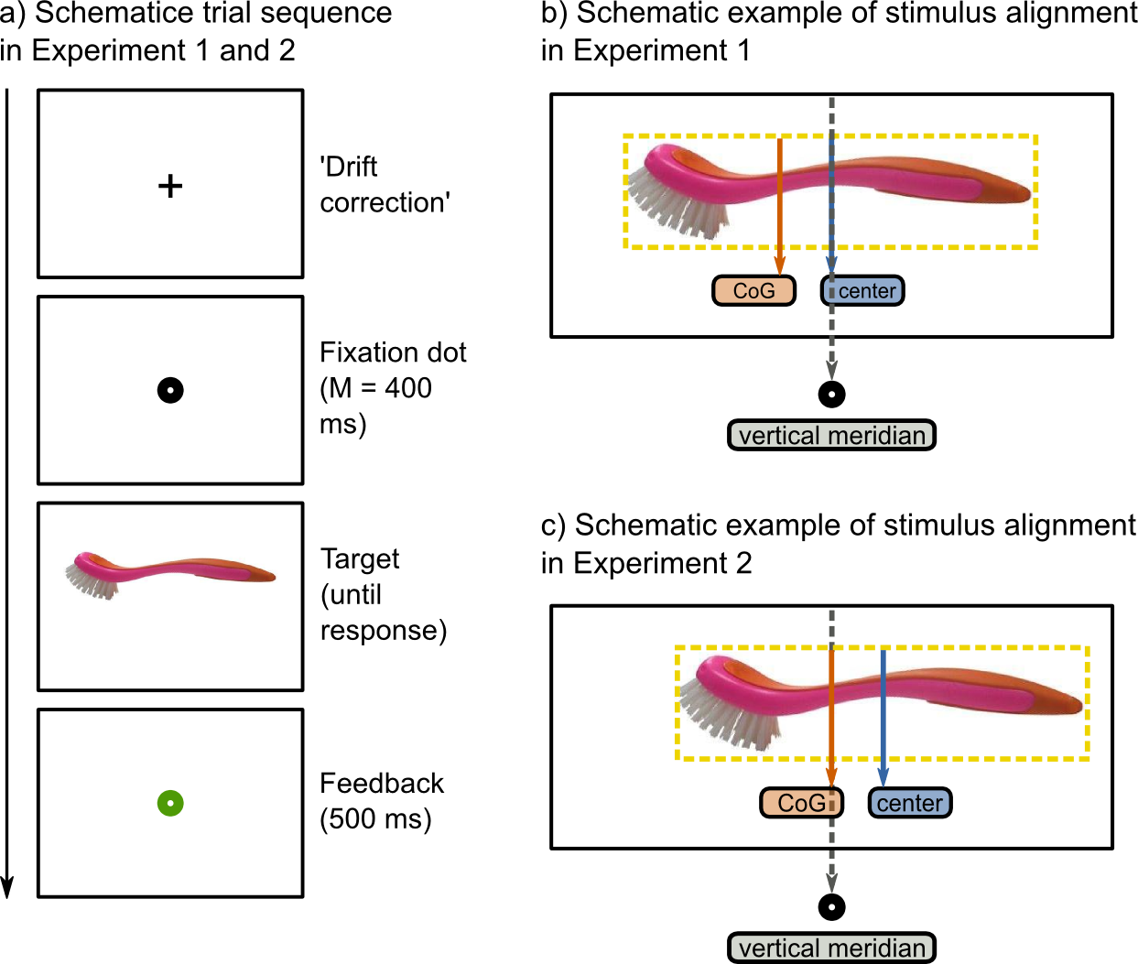
Figure 1: a) Schematic trial sequence of Experiment 1 and 2. b) In Experiment 1, the objects' absolute center was aligned with the vertical meridian. c) In Experiment 2, the objects' CoG was aligned with the vertical meridian.
Participants were instructed to look at the object and to categorize it as either a kitchen utensil or a garage tool by making a right- or a left-handed button press. A button press was effective only when participants gazed at the object (i.e. when vertical stable fixation position did not deviate more than 1.5° from the vertical center of the object). If a fixation check took more than 1000 ms to complete, it was considered as failed. In this case, participants heard a brief warning beep. The object remained on screen until a response was made or a timeout of 2500 ms occurred. Finally, a central red (for incorrect) or a green (for correct) fixation dot was displayed (500 ms) to inform participants about the correctness of their response.
The experiment contained six blocks of 96 trials, and commenced with six practice trials. The response rule (e.g. left for kitchen, right for garage) was swapped half-way the experiment, and the order of response rules was counterbalanced across participants. At the end of every block, participants were provided with their average response time and accuracy. If their accuracy was below 85 percent, they received a warning message asking them to be more accurate.

Data analysis
We normalized landing positions such that, irrespective of Handle Orientation (left or right) and the object's exact size, landing positions ranged between -.5 and .5. As a result, a value of .5 would mean that the eyes landed at the extreme border of the object's handle side, whereas a value of -.5 would indicate that the eyes landed at the extreme border of the objects' action-direction side. A value of 0 would indicate that the eyes landed exactly at the center. Our experiment was designed to only analyze the x-coordinates of the landing positions.
To calculate the objects' CoG, we applied an edge-detection algorithm and subsequently determined the objects' weighted center (see Appendix 1). This calculation revealed that, on average, the CoG of our stimuli was shifted (by about 1.25 % of the objects' width) towards the action-direction side. For only 3 out of 14 objects, the CoG was shifted towards the handle side. We emphasize that we do not consider this a confound or a disadvantage of our design. After all, the purpose was to investigate whether such (asymmetries in) stimulus properties (which most likely also hold for other stimulus sets of graspable objects) provide an alternative explanation for previously-reported handle-affordance or action-direction effects.
In Experiment 1, participants executed at least one (100%) or two (70%) saccades before making a manual response. The first saccade brought the peripherally-presented object into foveal vision, whereas the second saccade was made within the borders of the already foveated object. The purpose of Experiment 1 was to investigate whether the direction of these two saccades was influenced by the orientation of the object, and if so, to what extent this bias varied over time. Moreover, we compared landing positions with two different reference points: the objects' absolute center (i.e., the middle of the bitmap, which was aligned with the vertical meridian); and the objects' CoG. To this end, we conducted four separate linear mixed-effects (LME) analyses, with the four landing positions (initial saccades and refixations, relative to absolute center and relative to CoG) as the respective dependent variables. Participant and Object were used as random effects. To investigate the time course of any potential gaze bias, we included Saccade Latency (determined relative to stimulus onset) as a fixed effect. For the sake of completeness we also included Response Hand (left or right) and Target Eccentricity (continuous between ± 5 and ±7) as fixed effects. We did not include Gap Condition ('gap-zero' or 'overlap'), because this manipulation was used to influence the factor Saccade Latency (which we did include). Markov chain Monte Carlo (MCMC) simulation was used to estimate p values and 95% confidence intervals (Baayen, Davidson, & Bates, 2008).
The outcome of the analyses should be interpreted as follows: Firstly, the fitted function (plotted in dotted lines) represents the eyes' gaze bias over time. Shaded areas around these lines indicate 95% confidence intervals, which were determined on the basis of the function's intercept. Consequently, no overlap with the reference point (gray horizontal line) indicates that gaze bias is significantly different from zero (p < .05). The slope of the relationship between latencies and landing positions indicates whether the direction or the strength of the bias changed over time. It should be noted that the latter was performed especially to investigate the time course of the bias in initial saccade latencies, because possible competition between fast-decaying CoG effects (Coëffé & O’Regan, 1987; Vitu et al., 2006) and higher-level effects is particularly likely to occur early in time. For the refixations, the most important question was whether they differed from reference point, and, if so, in what direction (i.e., we were interested in the confidence intervals based on the intercept, but not in the slope). Therefore, although arguably a quadratic fit was more appropriate for the refixations, for the sake of simplicity we decided to fit linear regressions through both the landing positions.

Results
Trials were excluded according to the following criteria: No saccade was detected (0.04%), an incorrect response was given (5.43%), the initial saccade did not cross an imaginary line between the vertical center of the display and the smallest-possible target eccentricity (0.24%), an anticipatory saccade was made before stimulus onset (0.08%) or the gaze-contingent fixation checks failed (15.86%). Saccades were detected using the built-in EyeLink saccade/fixation-detection algorithm with the default parameters.
Firstly, we investigated the direction of initial saccades that participants made to bring the object into foveal vision. We found that initial saccades showed a bias relative to both reference points. However, strikingly, they did so in opposite manners. Relative to the objects' absolute center, initial saccades showed an average bias towards the objects' action-direction side (M = -0.039, SE = 0.004). In contrast, relative to the objects' CoG, initial saccades showed an average bias towards the objects' handle side (M = 0.021, SE.= 0.004). As can be seen from Figure 2, the effect of reference point on initial landing positions was particularly strong when saccade latency was low. For longer latencies, the eyes showed an average deviation towards the objects' action-direction side relative to both reference points. In line with this observation, our LME analyses revealed that initial landing positions correlated negatively with saccade latency (relative to absolute center: t = -8.32, p < .0001; relative to CoG: t = -8.56, p < .0001). This indicates that the longer the latency of an initial saccade, the stronger its bias towards the objects' action-direction side. The other effects were not significant.
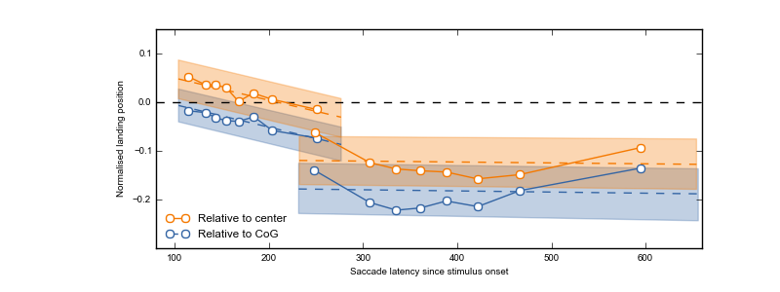Figure 2: Average gaze bias per saccade in Experiment 1 (left lines represent initial saccades, right lines represent within-object refixations) relative to the objects' absolute center (orange), and the objects' CoG (blue), as a function of time relative to stimulus onset. White markers indicate saccade-latency bin means, and are plotted for visualization purposes only. Orange and blue dotted lines indicate the linear regressions yielded by the four LME analyses, and shaded areas indicate 95% confidence intervals based on their respective intercepts. Consequently, no overlap with the reference point (gray horizontal line) indicates that gaze bias is significantly different from zero (p < .05). The slope of the relationship between latencies and landing positions indicates whether the direction or the strength of the bias changed over time.
Secondly, we investigated the direction of within-object refixations. We found that, on average, these saccades were directed towards the objects' action-direction side, regardless of reference point (relative to absolute center: M = -0.196, SE = 0.012; relative to CoG: M = -0.129, SE = 0.010,). As can be seen from the 95% confidence intervals in Figure 2, this bias remained present throughout the entire range of refixation latencies. This is in line with the above-described finding that the bias towards the action-direction side increased as a function of saccade latency. Nevertheless, it is important to note that 'time elapsed since stimulus onset' is not a sufficient explanation for participants' landing positions, because the bias was stronger for refixations than for initial saccades (see gap between the two on the y-axis), even though their latencies slightly overlapped (see overlap on the x-axis). None of the fixed effects were significant.
Finally, we investigated whether landing positions were normally distributed on a trial level. To this end, we plotted the distributions of the different landing positions. Given the effect of saccade latency on (initial) landing positions, we did this separately for the fastest, the slowest, and the intermediate saccades. More precisely, we firstly removed the between-subjects variability from saccade latencies (Cousineau, 2005). Next, we divided the resulting normalized saccade latencies into three equal bins. Then, per saccade-latency bin, we divided landing positions into 15 equal landing-position bins. The resulting distributions are shown in Figure 3, and, importantly, appear to be unimodal. Furthermore, the bin means of the slowest refixations in Figure 2 may give the impression that these saccades were redirected slightly towards the objects' CoG (as compared to earlier refixations). However, by looking at their distributions (Figure 3b and 3d, orange lines), it becomes clear that this average tendency comes from the fact that some some of the latest refixations were directed towards the objects' handle side, instead of the action-direction side. Thus, on a trial level, slower refixations were not more likely to land towards the CoG than earlier refixations.
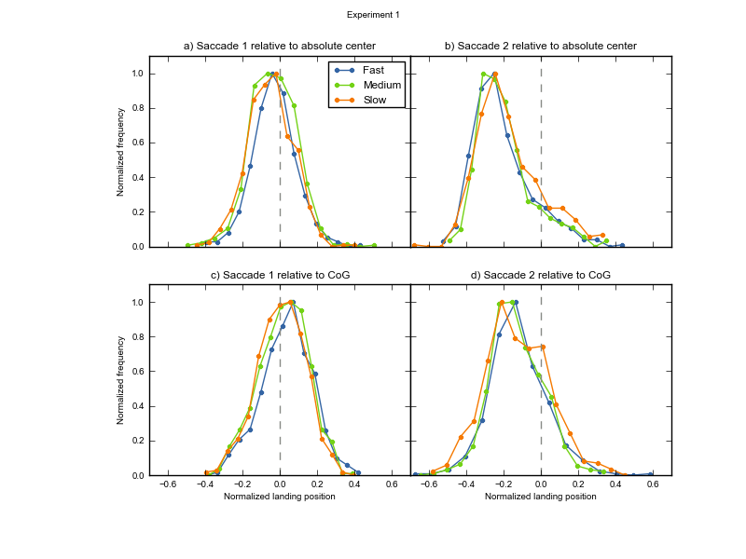Figure 3: Distributions of initial saccades (left) and refixations (right) in Experiment 1, relative to the objects' absolute center (upper) and relative to the objects' CoG (lower). Given the influence of saccade latency on landing positions, we plotted separate distributions for the 33% fastest (blue), medium (green), and slowest (orange) saccades. Gray dotted vertical lines indicate the reference point. In order to keep the range on the y-axis constant, we normalized absolute frequencies relative to their minimum and maximum frequency within a given distribution.

Discussion

Experiment 1 revealed that, on average, initial saccades did not land exactly at the objects' absolute center, nor exactly at its CoG. Instead, the eyes landed somewhere in between, especially when saccade latency was low. The fact that the direction of gaze bias reversed depending on whether landing positions were compared to the objects' absolute center or the objects' CoG, made us reluctant in interpreting this as a high-level, object-based effect. Rather, we considered the following: Possibly, when saccade latency was low, the eyes were drawn towards the CoG. However, on top of that, the eyes may have shown a tendency to land close to the vertical meridian. Regardless of the mechanism underlying this additional vertical-meridian bias (e.g., a systematic undershoot of oblique saccades along their axis, or a task strategy), the net result would be the pattern of results observed here. This line of reasoning is schematically depicted in Figure 4. We examined this possibility in Experiment 2.

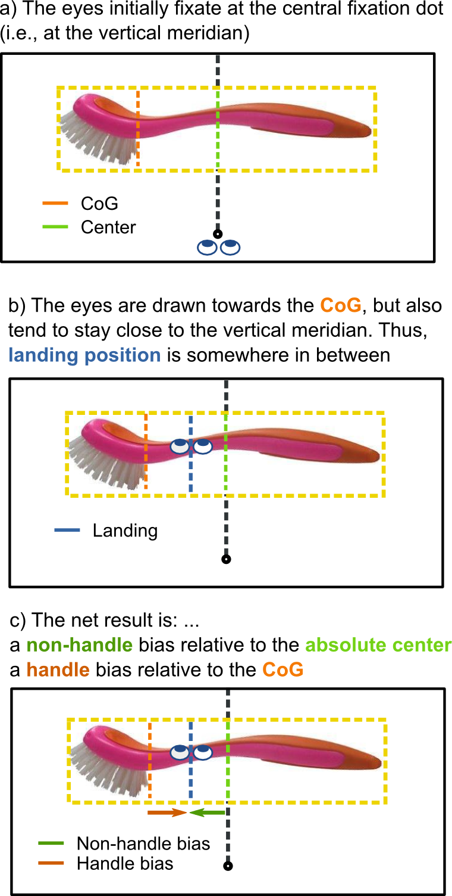

Figure 4: Schematic representation of how a CoG effect, combined with a tendency of the eyes to stay close to the vertical meridian, may result in a bias towards the objects' action-direction versus the objects' handle side, depending on the reference point (i.e. the objects' absolute center or its CoG, respectively). (Note that the CoG of the washing brush is exaggerated for the sake of clarity.)
Furthermore, Experiment 1 revealed that initial saccades with longer latencies, as well as subsequent within-object refixations, were systematically directed towards the objects' action-direction side. This is in line with the action-direction hypothesis (Roberts & Humphreys, 2006), because the eyes were biased in the direction of the action that is implied by the object.

Experiment 2
Experiment 2 further investigated the direction of saccades towards and within isolated graspable objects. It differed in a small but important manner from Experiment 1: In Experiment 2, the objects were aligned with their CoG (instead of their absolute center) on the vertical meridian (see Figure 1c). The reasoning behind this was as follows. Experiment 1 revealed that initial saccades significantly deviated from both reference points (i.e., the absolute center and the CoG). If this deviation was caused by a tendency to keep the eyes close to the vertical meridian (see Figure 4), in Experiment 2 the eyes should land approximately at the CoG (i.e. at the vertical meridian), irrespective of object orientation. In contrast, if the previously-observed initial deviation did reflect a higher-level, object-based effect, Experiment 2 should reveal a similar bias. In addition, Experiment 2 tested whether the action-direction bias in longer-latency initial saccades and subsequent within-object refixations, could be replicated.

Methods
Experiment 2 differed from Experiment 1 only on the following aspects. Eighteen different observers participated. Data from one participant were excluded from the analyses because he reported to be left-handed after having participated. Furthermore, we aligned the CoG (instead of the absolute center) of the objects with the vertical meridian (see Figure 2c). Finally, in Experiment 1 the criteria for the gaze-contingent fixation checks were set conservatively. This had led to the exclusion of a large number of trials. Therefore, in Experiment 2 we decided not to use any other on-line fixation checks than the one-point eye-tracker recalibration at the beginning of the trial.

Results
Trials were discarded on the basis of the following criteria: The EyeLink saccade-detection algorithm detected no saccades (2.76%), the initial saccade did not cross an imaginary line between the center and the smallest-possible target eccentricity (0.35%), an anticipatory saccade before stimulus onset was made (0.30%), or an erroneous response was given or a timeout occurred (6.26%).
As in Experiment 1, participants executed at least one (100%) or two (64%) saccades before categorizing the objects with a button press. We analyzed the landing positions of these two saccades relative to the CoG , which coincided with the vertical meridian. Firstly, trials on which landing position or saccade latencies deviated more than 2.5 SD from participants' mean were discarded. Then, as in Experiment 1, we used LME analyses to investigate whether landing positions were influenced by the objects' orientation, and, if so, whether this bias changed as a function of time. Again, Participant and Object were used as random effects, and Saccade Latency, Response Hand, and Target Eccentricity were used as fixed effects.
Firstly, we investigated the direction of initial saccades that participants made in order to bring the object into foveal vision. On average, initial saccades landed approximately on the CoG (M = -0.005, SE = 0.003). As can be seen from Figure 5, the tendency to land on the CoG was especially pronounced for saccades with short latencies. As in Experiment 1, initial saccades with longer latencies started to deviate away from the CoG, towards the objects' action-direction side. Indeed, as in Experiment 1, our LME analysis revealed an inverse relationship between latencies and landing positions of initial saccades, such that the later a saccade was executed, the stronger its bias towards the action-direction side (t = -4.31, p < .0001).
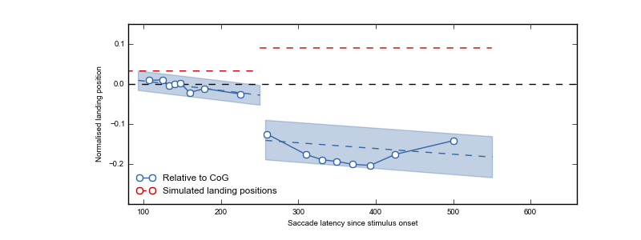Figure 5: Average gaze bias per saccade in Experiment 2 (left lines represent initial saccades, right lines represent within-object refixations), relative to the objects' CoG (which coincided with the vertical meridian) as a function of time relative to stimulus onset. Markers indicate saccade-latency bin means, and are plotted for visualization purposes only. Blue dotted lines indicate the linear regressions yielded by the two LME analyses, and shaded areas indicate 95% confidence intervals around their respective intercepts. Consequently, no overlap with the reference point (gray horizontal line) indicates that gaze bias is significantly different from zero (p < .05). The slope of the relationship between latencies and landing positions indicates whether the direction or the strength of the bias changed over time. Red-dotted horizontal lines indicate the landing positions of two simulated, saliency-driven saccades. These were simulated on the basis of saliency maps that were generated for the displays used in Experiment 2 (see 'Saliency Simulation').
Secondly, we investigated the direction of within-object refixations. Figure 5 shows that, as in Experiment 1, on average these were directed towards the action-direction side (M = -0.176, SE = 0.012). Moreover, as in Experiment 2, this bias remained present throughout the entire distribution of refixation latencies. In contrast to Experiment 2, the correlation between landing position and saccade latency even remained significant for refixations (t = -2.89, p = .004), indicating that, on average, the strength of the bias kept increasing over time. Again, however, 'time being elapsed since stimulus onset' is not sufficient to explain the strength of the action-direction bias, because initial saccades and refixations almost overlapped in latencies (see x-axis), but not in gaze bias (see gap on the y-axis). None of the other effects were significant.
Thus, Experiment 2 revealed that, on average, initial saccades with short latencies were directed towards the CoG rather than towards the handle or towards the action-direction side. However, from this finding alone, we cannot yet conclude that individual early initial saccades were most likely to land on the objects' CoG. Instead, the average landing position may be the net result of participants moving their eyes either towards the objects' handle side or towards the objects' action-direction side, with more or less equal probability. To exclude this possibility, we plotted distributions of landing positions in the same way as we did for Experiment 1. The results are shown in Figure 6, and suggest that the distributions were unimodally distributed.
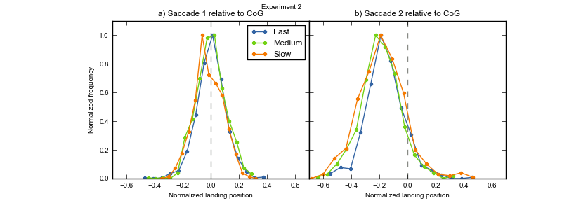Figure 6: Distributions of landing positions of initial saccades (left) and refixations (right) in Experiment 2, relative to the objects' CoG (gray dotted vertical lines). Given the influence of saccade latency on landing positions, we plotted separate distributions for the 33% fastest (blue), medium (green), and slowest (orange) saccades. In order to keep the range on the y-axis constant, we normalized absolute frequencies relative to the minimum and maximum frequency within a given distribution.

Saliency Simulation
Experiment 1 and Experiment 2 consistently revealed that only initial saccades with longer latencies, and within-object refixations, deviated towards the objects' action-direction side, suggesting that this bias takes time to build up, and is the result of higher-level, object-based processing. However, an alternative, low-level explanation cannot yet been ruled out. On average, the action-direction side of our stimuli may have been more salient than the handle side. As a consequence, after the CoG effect faded out, later saccades may have simply been saliency driven.
To examine this possibility, we generated saliency maps of the displays used in Experiment 2 (Itti et al., 1998), on the basis of which we simulated two saccades. These simulated saccades are a best effort to predict where the eyes would land if eye-movement guidance were purely determined by bottom-up visual saliency (Itti et al., 1998, see Appendix 2). The crucial question was whether the simulated saccades would show a similar pattern as the refixations observed in Experiment 2.
As can be seen from Figure 5 (second red line), this was not the case. Whereas participants tended to refixate the objects' action-direction side, simulated refixations did not show this bias. This discrepancy rules out the possibility that participants' refixations were solely saliency driven. Interestingly, whereas our CoG calculation was a relatively good predictor of the direction of participants' early initial saccades, the simulated first saccade predicted initial saccades less well (see Figure 5, firs red line). This is probably due to the fact that the saliency model that we used (Itti et al., 1998) does not take into account that visual acuity rapidly decays in the visual periphery.

Conclusion
Experiment 2 revealed that early initial saccades were directed towards the objects' CoG, whereas later initial saccades, as well as refixations, were directed towards the objects' action-direction part. The latter could not be explained by low-level visual saliency. This suggests that CoG effects occur early and decay rapidly, whereas the action-direction bias takes time to build up. Importantly, both the CoG and the action-direction bias appeared to be unimodally distributed, suggesting that, for example, the CoG effect is not a net result of participants gazing either towards the left, or towards the right, of the reference point.

General Discussion
The current study investigated to what extent low-level versus high-level effects determine where the eyes land on isolated daily-life objects. We operationalized low-level effects as saccadic averaging towards the objects' center-of-gravity (CoG), and high-level effects as visuomotor priming by object affordances. We found that early initial saccades were low-level driven, and landed on the objects' CoG. Only when saccade latency increased, we observed a systematic, object-related gaze bias.

A Low-Level Center-of-Gravity Effect
In visual displays containing two simple shapes, saccades typically reveal a global effect, such that they land on a location in between the two stimuli (Coren & Hoenig, 1972; Findlay, 1982; for reviews see Van der Stigchel & Nijboer, 2011; Vitu, 2008). This effect is typically interpreted as a tendency of the eyes to land on the (CoG) of the visual field, and its neural basis is assumed to be saccadic averaging in the superior colliculus (Findlay & Walker, 1999; Van Opstal & Van Gisbergen, 1989). As suggested by Vitu (2008), saccadic averaging may be the default mode of the visual system, which can only be overcome if saccadic programming time is sufficiently long. In line with this idea, several studies have shown that the CoG of a visual display even predicts where the eyes land during more natural behavior such as reading (Vitu, 1991), visual search (Zelinsky, 2008; Zelinsky et al., 1997), and scene viewing (Findlay & Brown, 2006; Melcher & Kowler, 2001).
Here, we show for the first time that presenting participants with photographs of isolated daily-life objects also yields a global effect. More precisely, we found that participants' early initial saccades landed at the CoG of peripherally presented objects. This finding is an important complement to the above-mentioned literature, and supports the hypothesis that saccadic averaging is a universal phenomenon that occurs independent of stimulus type or task requirements, but only when saccadic programming time is short (Vitu, 2008).
As mentioned in the Introduction, we are not the first to investigate initial landing positions on isolated daily-life objects. For example, Henderson (1993), and Foulsham and Underwood (2009) found that initial on-object landing positions were distributed around the objects' center (for similar findings on objects embedded in natural scenes, see Foulsham & Kingstone, 2013; Nuthmann & Henderson, 2010). However, in these studies the CoG of the stimuli was not taken into account. Therefore, it remains unclear whether participants aimed for the objects' center per se (as a top-down strategy, cf. McConkie et al., 1988), or whether their eyes were simply pulled towards the objects' CoG. Our current results are in line with the latter, because we found that initial saccades landed at the objects' CoG (Experiment 2) rather than at its absolute center (Experiment 1). Still, because our study was not designed to contrast both possibilities, we cannot draw any firm conclusions from this observation.

High-Level Object-Affordance Effects
As mentioned in the Introduction, several researchers have proposed that visuomotor priming biases visuospatial attention. Intriguingly, however, previous studies were equivocal with regard to the direction of this bias. Whereas Myachykov and colleagues (2013) found that the eyes are automatically drawn towards an objects' graspable part (i.e. the handle of a teapot), Roberts and Humphreys (2006) found an attentional shift in the direction of the action that is implied by the object (i.e., towards the pouring part of a teapot).

A High-Level Action-Direction Bias
The current results tip the balance in favor of the action-direction hypothesis. As soon as the low-level CoG effect decayed (i.e., when saccade latencies increased), saccades were biased towards the objects' action-direction side. Importantly, this bias could not be explained by the objects' low-level features, because a saliency-model simulation (Itti et al., 1998) revealed that simulated, purely saliency-driven saccades landed elsewhere. Although the here-observed gaze bias is in line with the action-direction hypothesis, we note that it might also reflect a tendency to move the eyes towards the part of the object that is most informative for object identification. Future studies that simultaneously manipulate both action direction and semantic informativeness should help disentangle the contribution of both processes to eye guidance.
Regardless of the underlying mechanism, we found that the action-direction bias takes time to build up. Whereas CoG effects decayed rapidly, the action-direction bias of initial saccade increased over time. Refixations showed the same bias to an even larger extent. This finding is consistent with previous studies showing that the contribution of low-level, default mechanisms (Vitu, 2008) dissipate over time, thereby making room for higher-level effect to influence eye guidance (De Graef, Christiaens, & d’ Ydewalle, 1990; Henderson et al., 1999; Parkhurst, Law, & Niebur, 2002; Van Zoest, Donk, & Theeuwes, 2004, but see also Loftus & Mackworth, 1978).
Nevertheless, these separate time courses do not explain all variance between initial saccades and subsequent refixations, because the very-latest initial saccades still showed a much smaller action-direction bias than the very-earliest refixations. The remaining difference could possibly be explained by the fact that initial saccades were made towards a peripherally presented stimulus (in order to foveate it), whereas refixations were made within an already-foveated stimulus. Probably, it is easier to determine which part of the object is the optimal saccade-target location, and to guide the eyes accordingly, when the object is already in (para)foveal vision as compared to when it is still in peripheral vision.

No High-Level Handle-Affordance Bias
In contrast to what has previously been shown by Myachykov and colleagues (2013), in our study participants' eyes did not deviate towards the objects' handle at any point in time. The discrepancy between their and our results is best explained by the different analyses employed: whereas we looked at landing position, Myachykov and colleagues (2013) looked at 'proportional dwell time', which was calculated as the total fixation on a given area of interest (i.e., the handle versus the 'body' of the object) divided by the size of the area in pixels. Their results showed that participants spent proportionally more time looking at objects' handles, as compared to objects' bodies. However, we believe that using proportional dwell times as a dependent measure is only sound when the objects' low-level properties, such as its CoG, are taken into account. Without doing so, an analysis such as the one carried out by Myachykov and colleagues (2013) may lead to the reported pattern of results even when handles and bodies were fixated to the same extent, simply because the bodies contained more pixels than the handles (which typically appears to be the case for action-related objects, see Methods Experiment 1). For example, when participants gazed 500 ms on an object's body, containing 100 pixels, and another 500 ms on the handle, containing only 10 pixels, proportional dwell time is longer on the latter than on the former area of interest. Interpreting this as evidence for the idea that objects' graspable parts automatically attract attention appears premature.
A related point is that our current results, and their discrepancy with previous findings (Myachykov et al., 2013), emphasize how important it is to take a stimulus' low-level features (e.g. CoG or saliency) into account. For example, in Experiment 1, we found opposite results for early initial landing positions depending on whether or not we corrected for the objects' CoG. Applying only one or the other analysis could have resulted in a striking, yet incorrect, conclusion: a bias towards the objects' handle (or towards its action-direction side, depending on the chosen reference point) at the earliest possible processing stage. Therefore, we believe that it should be a prerequisite for studies using real objects as stimuli to guarantee that a potential higher-level effect (e.g. an affordance effect) is not likely to be explained by the stimuli's low-level features. Such care should not only be taken when measuring bottom-up-driven oculomotor behavior, but also when measuring other cognitive processes, such as visuospatial attention.

Conclusions
In sum, we investigated to what extent low-level CoG effects versus high-level object-affordance effects determine where the eyes land on isolated daily-life objects. We found that when programming time of initial saccades was short, the eyes were drawn towards the CoG of the object. This supports the hypothesis that the global effect (Coren & Hoenig, 1972; Findlay, 1982), as caused by saccadic averaging in the superior colliculus (Findlay & Walker, 1999; Van Opstal & Van Gisbergen, 1989), is a task-independent default mechanism (Vitu, 2008). When saccade latencies increased, the eyes started to deviate from the CoG, and showed a systematic gaze bias towards the objects' action-direction part. In line with previous studies (cf. e.g. Henderson et al., 1999; Parkhurst et al., 2002; Van Zoest et al., 2004), we conclude that low-level CoG effects occur early and decay rapidly, whereas higher-level, object-related effects take time to build up .

Acknowledgements
L. van der Linden was supported by a grant ('allocation de recherche') from the French Ministry of Research (2012-2015), and S. Mathôt was supported by ERC grant 230313 attributed to Jonathan Grainger. We thank Sarah Moulay and Emmanuel Santune for collecting the data of Experiment 2.

Appendix 1: Center-of-gravity calculation
To calculate the center of gravity (CoG) of our stimuli we applied an edge-detection algorithm (i.e. Sobel operator) to the original bitmap image. Next, we calculated the weighted average contrast of the Sobel-filtered image. This procedure ensured that parts of the object where local contrast was high were weighted more heavily than parts of the object where contrast was low. Examples of high-contrast parts are the objects' borders (where contrast with the white background is typically high) and 'rough' surfaces within the object, such as the hairs of a tooth brush. Examples of low-contrast parts are smoothed, continues surfaces, such as the blade of a knife.

Appendix 2: Saliency maps
To obtain simulated, saliency driven eye movements, we did the following. Firstly, for every trial display we generated a saliency map using the NeuroMorphic vision toolkit (Itti, Koch, & Niebur, 1998). Next, simulated eye movements were determined based on the peak of local contrast of the saliency map, combined with a simple inhibition-of-return mechanism. The latter avoided that all simulated eye movements were generated towards the same location (i.e. the location where saliency was highest). Instead, once fixated, the just-fixated location got temporarily inhibited, such that subsequent saccades were directed elsewhere (i.e., towards the next-most salient location).
Saliency maps of the displays used in Experiment 2 were obtained with the following command:

ezvision --in=[input image] -T --output-frames=0-4@EVENT --out=png --textlog=[output log] -+

Appendix 3: Contrast Manipulation
Contrast between stimulus and background should have an influence on the outcome of our CoG calculation. We therefore included a contrast manipulation in our design to investigate (1) whether our CoG calculation was sensitive to this manipulation, and (2) whether it influenced participants' eye movements to a similar extent.
To this purpose, we applied a mask gradient, generated in OpenSesame (Mathôt et al., 2012) by using PsyhoPy (Peirce, 2007), to our stimuli. This led to a degradation of the original stimulus at either the left or the right side (see Figure A1). Note that these contrast-degraded trials were not included in the analyses described in the main text. For the analyses described below, only the contrast-degraded conditions were included.
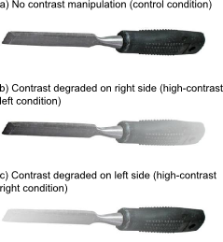
Figure A1: The experimental factor Contrast had three levels: Control (a), High-Contrast Left (b), and High-Contrast Right (c). Only the Control condition was included in the analyses described in the main text. Only the High-Contrast Left and High-Contrast Right conditions were included in the analyses described here.

Contrast Effect on CoG calculation
As expected, the contrast manipulation influenced the CoG calculation. In the control condition (see Figure A1a), on average the CoG was shifted slightly towards objects' action-direction side (1.25% of the objects' width, see also main text). If contrast on the action-direction side was preserved (i.e. contrast on the handle side was degraded, see Figure A1b), this bias was slightly stronger (1.56%). On the other hand, if contrast on the handle side was preserved (i.e. contrast on the action-direction side was degraded, see Figure A1c), the average CoG was shifted slightly towards the handle (0.12%).

Contrast Effect on Landing Postions
We investigated the effect of contrast on participants' landing positions. In Experiment 2, objects were presented with their CoG aligned on the vertical meridian. Therefore, we predicted that initial landing positions would not deviate from this reference point, regardless of contrast manipulation. For Experiment 1 (where the objects' absolute center was aligned on the vertical meridian) the predictions were less clear. Therefore, we only tested the effect of contrast for Experiment 2.
Firstly, we normalized landing positions such that, irrespective of contrast manipulation (left or right side degraded) and the objects' exact size, landing positions ranged between -.5 and .5. As a result, positive values indicated a gaze bias towards the high-contrast side, and negative values indicated a gaze bias towards the low-contrast side. A value of 0 would indicate that a saccade was not influenced by our contrast manipulation, but, instead, landed on the objects' CoG.
Next, we carried out LME analyses for the landing positions of initial saccades and refixations separately. Participant and Object were used as random effects, and Saccade Latency, Handle Orientation (left or right), Response Hand (left or right) and Target Eccentricity were used as fixed effects. Markov chain Monte Carlo (MCMC) simulation was used to estimate p values and 95% confidence intervals (Baayen et al., 2008). Trials on which saccade latency or landing position deviated more than 2.5 SD's from participants' means were discarded.
Our analysis revealed an effect of contrast manipulation on initial landing positions. As can be seen in Figure A2, initial saccades slightly deviated from the CoG in the direction of the objects' high-contrast side (M = 0.011, SE = 0.002). This suggests that, after we manipulated the contrast of our stimuli artificially, our CoG calculation slightly underestimated the 'real' CoG. Importantly, however, this underestimation is small, compared with the actual gaze bias observed in the experiments, which shows that our simple edge-detection algorithm is a fairly good approximation of the 'true' CoG. Furthermore, the LME analysis revealed an effect of saccade latency (t = -2.242, p = .0250), indicating that when saccade latency increased, the initial deviation towards the objects' high-contrast side become weaker. We also found an effect of target eccentricity (t = 2.500, p = .0125), indicating that the bias towards the high-contrast side was larger for objects presented in the upper visual (M = 0.016, SE = 0.003) field than for objects presented in the lower visual field (M = 0.007, SE = 0.003).
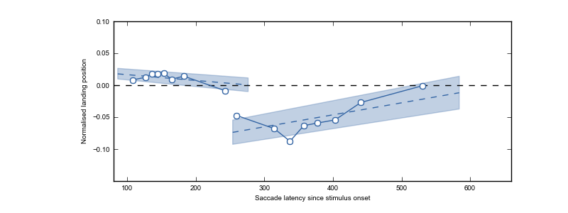Figure A2: Average gaze bias per saccade in Experiment 2 (left lines represent initial saccades, right lines represent within-object refixations), relative to the objects' CoG (which coincided with the vertical meridian) as a function of time relative to stimulus onset. Markers indicate saccade-latency bin means, and are plotted for visualization purposes only. Blue dotted lines indicate the linear regressions yielded by the two LME analyses, and shaded areas indicate 95% confidence intervals around their respective intercepts. Consequently, no overlap with the reference point (gray horizontal line) indicates that gaze bias is significantly different from zero (p < .05). The slope of the relationship between latencies and landing positions indicates whether the direction or the strength of the bias changed over time.
As can be seen from Figure A2, our contrast manipulation also affected refixations. Interestingly, the contrast effect on refixations was in the opposite direction as the contrast effect on initial saccades: Relative to the (possibly slightly underestimated) CoG, refixations were deviated towards the objects' low-contrast side (M = -0.05, SE = 0.004). Although contradictory at first sight, this is probably best explained as a high-level compensatory effect: Participants directed their gaze towards the part of the object that was less visible, in order to maximize visual-information uptake. Furthermore, we found an effect of saccade latency (t = 3.360, p = 0008), indicating that the bias towards the low-contrast side decreased over time. As can be seen from the distributions in Figure A3, the latter does not mean that later-occurring refixations were likely to land on the objects' CoG on a trial level. Instead, they were distributed bimodally, indicating that they were either directed towards the high-contrast or the low-contrast side. Finally, our LME analysis revealed an effect of response hand (t = -2.64, p = .008), indicating that the bias towards the low-contrast side was larger when participants responded with their right hand (M = -0.065, SE = 0.007) as compared to their left hand (M = -0.042, SE = 0.007).
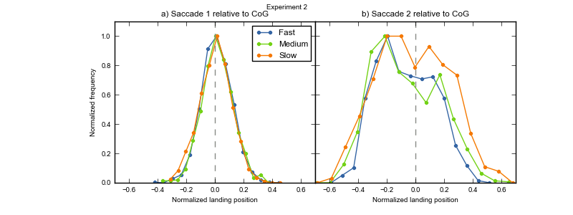
Figure A3: Distributions of landing positions of initial saccades (left) and refixations (right) in Experiment 2, relative to the objects' CoG (gray dotted vertical lines). Given the influence of saccade latency on landing positions, we plotted separate distributions for the 33% fastest (blue), medium (green), and slowest (orange) saccades. In order to keep the range on the y-axis constant, we normalized absolute frequencies relative to the minimum and maximum frequency within a given distribution.

References
Baayen, R. H., Davidson, D. J., & Bates, D. M. (2008). Mixed-effects modeling with crossed random effects for subjects and items. Journal of Memory and Language, 59(4), 390–412.
Brodeur, M. B., Dionne-Dostie, E., Montreuil, T., Lepage, M., & Op de Beeck, H. P. (2010). The Bank of Standardized Stimuli (BOSS), a new set of 480 normative photos of objects to be used as visual stimuli in cognitive research. PloS ONE, 5(5), e10773.
Chao, L. L., & Martin, A. (2000). Representation of manipulable man-made objects in the dorsal stream. NeuroImage, 12(4), 478–484.
Coëffé, C., & O’Regan, J. K. (1987). Reducing the influence of non-target stimuli on saccade accuracy: predictability and latency effects. Vision Research, 27(2), 227–240.
Coren, S., & Hoenig, P. (1972). Effect of non-target stimuli upon length of voluntary saccades. Perceptual and Motor Skills, 34(2), 499–508.
Cousineau, D. (2005). Confidence intervals in within-subject designs: A simpler solution to Loftus and Masson’s method. Tutorial in Quantitative Methods for Psychology, 1(1), 42–45.
Craighero, L., Fadiga, L., Umiltà, C., & Rizzolatti, G. (1996). Evidence for visuomotor priming effect. NeuroReport, 8(1), 347.
De Graef, P., Christiaens, D., & d’ Ydewalle, G. (1990). Perceptual effects of scene context on object identification. Psychological Research, 52(4), 317–329.
Deubel, H., Findlay, J., Jacobs, A., & Brogan, D. (1988). Saccadic eye movements to targets defined by structure differences. Eye Movement Research: Physiological and Psychological Aspects, 107–145.
Findlay, J. M. (1982). Global visual processing for saccadic eye movements. Vision Research, 22(8), 1033–1045.
Findlay, J. M., & Brown, V. (2006). Eye scanning of multi-element displays: II. Saccade planning. Vision Research, 46(1), 216–227.
Findlay, J. M., & Walker, R. (1999). How are saccades generated? Behavioral and Brain Sciences, 22(04), 706–713.
Foulsham, T., & Kingstone, A. (2013). Optimal and preferred eye landing positions in objects and scenes. The Quarterly Journal of Experimental Psychology, 66(9), 1707–17288.
Foulsham, T., & Underwood, G. (2009). Does conspicuity enhance distraction? Saliency and eye landing position when searching for objects. The Quarterly Journal of Experimental Psychology, 62(6), 1088–1098.
Gibson, J. J. (1977). The theory of affordances. Perceiving, Acting, and Knowing: Toward an Ecological Psychology, 67–82.
Gibson, J. J. (1979). The Ecological Approach to Visual Perception. Boston: Houghton Mifflin.
Grèzes, J., Tucker, M., Armony, J. L., Ellis, R., & Passingham, R. E. (2003). Objects automatically potentiate action: an fMRI study of implicit processing. European Journal of Neuroscience, 17(12), 2735–2740.
Handy, T. C., Grafton, S. T., Shroff, N. M., Ketay, S., & Gazzaniga, M. S. (2003). Graspable objects grab attention when the potential for action is recognized. Nature Neuroscience, 6(4), 421–427.
Henderson, J. M. (1993). Eye movement control during visual object processing: Effects of initial fixation position and semantic constraint. Canadian Journal of Experimental Psychology/Revue Canadienne de Psychologie Expérimentale, 47(1), 79.
Henderson, J. M. (2003). Human gaze control during real-world scene perception. Trends in Cognitive Sciences, 7(11), 498–504.
Henderson, J. M., Weeks Jr, P. A., & Hollingworth, A. (1999). The effects of semantic consistency on eye movements during complex scene viewing. Journal of Experimental Psychology: Human Perception and Performance, 25(1), 210.
He, P., & Kowler, E. (1991). Saccadic localization of eccentric forms. Journal of the Optical Society of America A, 8(2), 440–449. doi:10.1364/JOSAA.8.000440
Itti, L., & Koch, C. (2000). A saliency-based search mechanism for overt and covert shifts of visual attention. Vision Research, 40(10), 1489–1506.
Itti, L., & Koch, C. (2001). Computational modelling of visual attention. Nature Reviews Neuroscience, 2(3), 194–203.
Itti, L., Koch, C., & Niebur, E. (1998). A model of saliency-based visual attention for rapid scene analysis. IEEE Transactions on Pattern Analysis and Machine Intelligence, 20(11), 1254–1259.
Kaufman, L., & Richards, W. (1969). Spontaneous fixation tendencies for visual forms. Perception & Psychophysics, 5(2), 85–88.
Kowler, E., & Blaser, E. (1995). The accuracy and precision of saccades to small and large targets. Vision Research, 35(12), 1741–1754.
Land, M. F., & Hayhoe, M. (2001). In what ways do eye movements contribute to everyday activities? Vision Research, 41(25-26), 3559–3565.
Land, M. F., Mennie, N., & Rusted, J. (1999). The roles of vision and eye movements in the control of activities of daily living. Perception, 28(11), 1311–1328.
Loftus, G. R., & Mackworth, N. H. (1978). Cognitive determinants of fixation location during picture viewing. Journal of Experimental Psychology: Human Perception and Performance, 4(4), 565.
Mathôt, S., Schreij, D., & Theeuwes, J. (2012). OpenSesame: An open-source, graphical experiment builder for the social sciences. Behavior Research Methods, 1–11.
McConkie, G. W., Kerr, P. W., Reddix, M. D., & Zola, D. (1988). Eye movement control during reading: I. The location of initial eye fixations on words. Vision Research, 28(10), 1107–1118.
Melcher, D., & Kowler, E. (2001). Visual scene memory and the guidance of saccadic eye movements. Vision Research, 41(25-26), 3597–3611.
Moreno-Martínez, F. J., & Montoro, P. R. (2012). An ecological alternative to Snodgrass & Vanderwart: 360 high quality colour images with norms for seven psycholinguistic variables. PloS ONE, 7(5), e37527.
Myachykov, A., Ellis, R., Cangelosi, A., & Fischer, M. H. (2013). Visual and linguistic cues to graspable objects. Experimental Brain Research, 229(4), 545–599. doi:10.1007/s00221-013-3616-z
Nuthmann, A., & Henderson, J. M. (2010). Object-based attentional selection in scene viewing. Journal of Vision, 10(8), 1–19.
Parkhurst, D., Law, K., & Niebur, E. (2002). Modeling the role of salience in the allocation of overt visual attention. Vision Research, 42(1), 107–123.
Peirce, J. W. (2007). PsychoPy—psychophysics software in Python. Journal of Neuroscience Methods, 162(1), 8–13.
Posner, M. I., Snyder, C. R., & Davidson, B. J. (1980). Attention and the detection of signals. Journal of Experimental Psychology: General, 109(2), 160–174.
Rayner, K. (1998). Eye movements in reading and information processing: 20 years of research. Psychological Bulletin, 124(3), 372.
Rayner, K., Liversedge, S. P., Nuthmann, A., Kliegl, R., & Underwood, G. (2009). Rayner’s 1979 paper. Perception, 38(6), 895.
Richards, W., & Kaufman, L. (1969). “Center-of-gravity” tendencies for fixations and flow patterns. Perception & Psychophysics, 5(2), 81–84.
Roberts, K. L., & Humphreys, G. W. (2006). Action-related objects influence the distribution of visuospatial attention. Quarterly Journal of Experimental Psychology, 64(4), 669–688. doi:10.1080/17470218.2010.520086
Rolfs, M., & Vitu, F. (2007). On the limited role of target onset in the gap task: Support for the motor-preparation hypothesis. Journal of Vision, 7(10), 1–20. doi:10.1167/7.10.7
Saslow, M. G. (1967). Effects of components of displacement-step stimuli upon latency for saccadic eye movement. Journal of Optical Society of America, 57(8), 1024–1029.
Tatler, B. W., Hayhoe, M. M., Land, M. F., & Ballard, D. H. (2011). Eye guidance in natural vision: Reinterpreting salience. Journal of Vision, 11(5).
Tucker, M., & Ellis, R. (1998). On the relations between seen objects and components of potential actions. Journal of Experimental Psychology-Human Perception and Performance, 24(3), 830–846.
Tucker, M., & Ellis, R. (2001). The potentiation of grasp types during visual object categorization. Visual Cognition, 8(6), 769–800.
Vainio, L., Ellis, R., & Tucker, M. (2007). The role of visual attention in action priming. The Quarterly Journal of Experimental Psychology, 60(2), 241–261.
Van der Stigchel, S., & Nijboer, T. C. W. (2011). The global effect: what determines where the eyes land. Journal of Eye Movement Research, 4(2), 1–13.
Van Opstal, A. J., & Van Gisbergen, J. A. M. (1989). A model for collicular efferent mechanisms underlying the generation of saccades. Brain, Behavior and Evolution, 33(2-3), 90–94.
Van Zoest, W., Donk, M., & Theeuwes, J. (2004). The role of stimulus-driven and goal-driven control in saccadic visual selection. Journal of Experimental Psychology: Human Perception and Performance, 30(4), 746.
Vitu, F. (1991). The existence of a center of gravity effect during reading. Vision Research, 31(7), 1289–1313.
Vitu, F. (2008). About the global effect and the critical role of retinal eccentricity: Implications for eye movements in reading. Journal of Eye Movement Research, 2(3), 1–18.
Vitu, F., Lancelin, D., Jean, A., & Farioli, F. (2006). Influence of foveal distractors on saccadic eye movements: A dead zone for the global effect. Vision Research, 46(28), 4684–4708.
Zelinsky, G. J. (2008). A theory of eye movements during target acquisition. Psychological Review, 115(4), 787–835.
Zelinsky, G. J., Rao, R. P. N., Hayhoe, M. M., & Ballard, D. H. (1997). Eye movements reveal the spatiotemporal dynamics of visual search. Psychological Science, 8(6), 448–453.

